Peter Sands MANF-3000

Grouped Data Lab

I was given an excel sheet that had a random assortment of data points from samples with different Rockwell C hardness readings and had to sort through this data and compare it to the spec. I first found the maximum and minimum values which were 57.5 and 53.1 respectively. These values fell within the tolerance required of 55.0 ± 4.0. I then found the average value of the data set to be 55.4 which is very close to the nominal value. I then found the standard deviation to measure the dispersion of the data; which came out to 1.113. Kurtosis, which is a measurement of “tailedness”, is used to described the shape of the data compared to a normal distribution curve. Likewise, skewness is a value that describes how much data is shifted to one side of the curve. The typical value of kurtosis for a normal distribution is 3.0 which is a bit larger than for this data set which has a value of 1.5. This means that the data is a bit more spread out from the mean than a standard normal curve. A skewness value of 0 would mean that the data is symmetrical about the mean. Our returned value of 0.972 means that more data points are above our mean of 55.4. Our value for c­p (process capability) of 1.198 means that the data all falls within spec and none of the samples are defects. cpk instead measures the same thing as cp but also takes into account the mean being centered on the nominal value for the spec. This means that the returned value of 1.078 being lower than the value for cp means that the mean is a little off from the nominal value. The bell curve overlaid on top of the chart is to show that normal distribution statistics were used to come to our conclusions mentioned above.

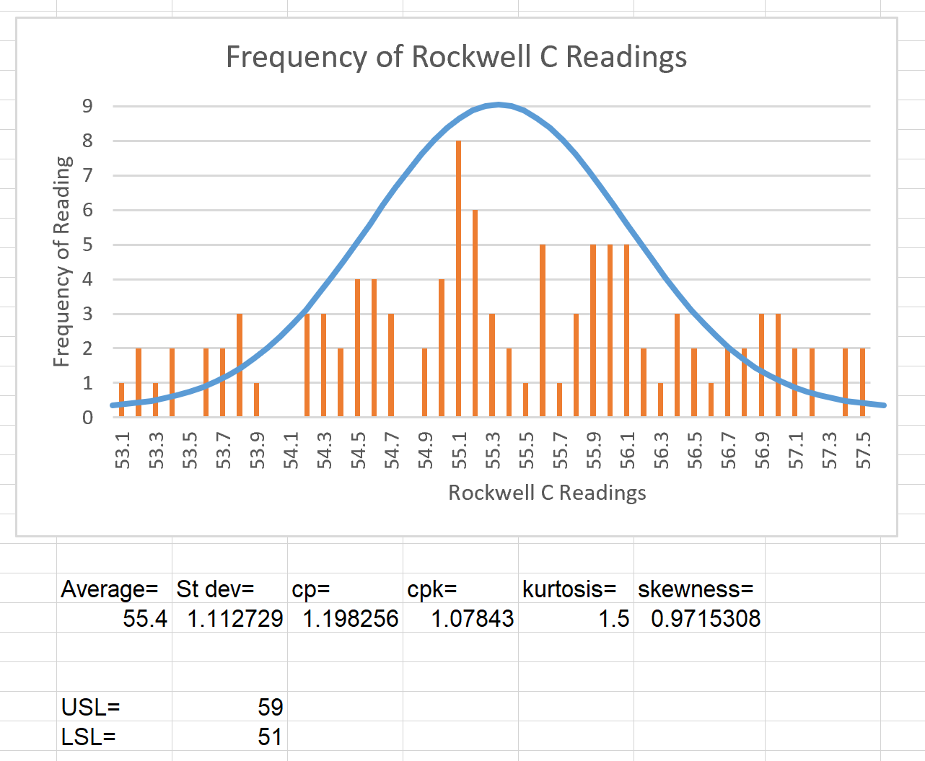

Figure : Output from Excel