Peter Sands MANF-3000

Quality Engineering Report

Shaft diameters that were cut by lathes N-5 and N-7 were to be analyzed to see if the process capability ratio showed that the process was capable. Originally, histograms were created to compare the subgroup readings to a normal bell curve to see how they compare. The micrometer readings from the shafts off of lathe N-5 seem to be more normally distributed as seen in the graphs below.

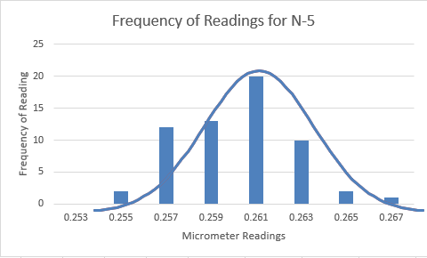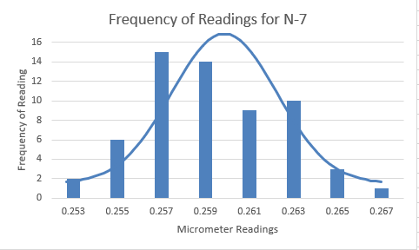

Grouped data analysis was then performed on the micrometer readings to see if the processes are capable and stable. The readings from lathes N-5 and N-7 c­p were 0.660 and 0.533 respectively which shows that the processes are neither stable nor capable since the values are both less than 1. Statistical process control was then used to compare to the cp values from grouped data analysis. After determining the control limits for both the averages and the range, the calculations returned a cp­ value of 0.650 and 1.006 for lathes N-5 and N-7 respectively. This means that the process for lathe N-7 is more capable than that of lathe N-5. This is due to the lower average range of readings per subgroup in the readings from lathe N-7. The graphs for these calculations are shown below.

